Abi Taylor
Abi@paccshropshire.org.uk
Annie Taylor
Annie@paccshropshire.org.uk
Abstract
This report has been developed to reflect on the success and challenges of the delivery of PACCs Healthy Lives Programme as part of our Preparation For Adulthood development work. The programme was delivered across the summer of 2022 with the key aims to increase health outcomes, improve infection control, and support families to better understand the benefits of living well and preparing to live well at the earliest stages of their PFA journey.
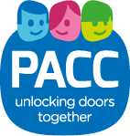
Healthy Lives Programme Report
Preparation for Adulthood Delivery Programme

Contents
1.0 | Summary………………………….. | Page 3
2.0 | Recommendations……………….. | Page 4
3.0 | Background……………………….. | Page 5
4.0 | Designing The Programme……... | Page 8
5.0 | Recruitment……………………….. | Page 11
6.0 | Characteristics of Participants….. | Page 13
7.0 | Programme Delivery……………... | Page 15
8.0 | Evaluation…………………………. | Page 18
9.0 | Programme Cost………………… | Page 23
10.0 | Appendices………………………... | Page 24

1.0 Summary
1.1 The Parent and Carers Council (PACC) Shropshire was commissioned in February 2022 to deliver a project to promote “Healthy Lives” to an often hard to reach cohort, 14-25- year- olds with special educational needs. (SEN)The funding originated from the drive to improve infection control and awareness of infection control after the COVID pandemic amongst one of the most vulnerable groups of people.
1.2 The project recognised the importance of working with this cohort of young people as part of the Preparing for Adulthood Pathway (PFA) in Shropshire and the impact it could have on their future “Healthy Lives”. To engage young people with this “not very cool” subject would be challenging and the project would need to be fun, flexible, innovative, creative and easy to access. It was also crucial to set the project in the future landscape that a young person with special needs might and could see themselves at the end of their educational journey. Council led Day Opportunity Providers and other SEN Day Opportunity Providers would be the key delivery partners in this project.
1.3 The Healthy Lives pilot programme was developed with the support of 14 Day Opportunity providers. It was launched at Derwen College on 25 July and finished on 30th August followed by a Celebration event at Derwen again on 25 October 2022. The programme offered 33 different activity sessions across the County and offered 246 places (76% allocated) and 139 places filled (56%). In total 60 young people attended; 56 young people signed up; 49 (88%) attended with 11 other young people joining activities.
1.4 The programme was evaluated by undertaking 3 online surveys with parent/carers; providers; asking young people to fill out feedback cards. Overall, the feedback was extremely positive across all the evaluations. It is considered that the aims of the programme have been met. The project has made a real impact and difference to young people and families in Shropshire. PACC would like to thank all our delivery partners and parents for working with us to make this happen and looks forward to taking the learning lessons forward.

2.0 Recommendations

- Continue to develop an offer from day opportunity services for 14- 25 SEN group- particularly those with more complex needs

- Explore the use of day opportunity buildings outside of their current use e.g., weekends and evenings.

- Develop an easily accessible day opportunities offer as part of the PFA pathway for young people and families.

- Continue to focus and promote healthy living and being active for this group of young people to support their physical and mental wellbeing

- Continue to support families whose young people participated in the programme with the PFA navigators and referring where appropriate to other activities and support.

- Disseminate and share good practice with partners particularly Shropshire Council and those commissioning Short Breaks provision

- PACC to share lessons learnt with Funders and plan next steps at meeting planned for 1st November 2022

3.0. Background
3.1 It is important for young people to establish healthy habits to ensure these continue into adult life, however, data shows that children and young people with SEND are more at risk of having lower activity levels, unhealthy diets, being under or overweight or suffering from poor mental health. (See https://www.activityalliance.org.uk/how-we-help/research/5658-my-active-future-including-every-child )
Being active can bring lots of benefits, helping young people to develop their confidence and build friendships, as well as improving physical heath. This was recognised by the Chief Medical Officer in recommendations for physical activity levels for disabled children and disabled young people. These state :
Getting and staying active is about:
- equality
- inclusivity
- finding what’s fun
- exploring what activities make you feel good
Benefits of physical activity are:
- meeting new people
- improved confidence and concentration
- a sense of achievement
- improved mental health
- being calmer, less stressed
- improved balance and coordination
- improved strength and motor skills
How much physical activity should I do?
- For good health benefits, do 20 minutes of physical activity per day.
- When starting, build up slowly. Ask: can you do this today?
- Do bitesize chunks of physical activity throughout the day.
- Do challenging but manageable strength and balance activities 3 times per week.
- Small amounts of physical activity are good for you as well.
https://www.gov.uk/government/publications/physical-activity-guidelines-disabled-children-and-disabled-young-people/physical-activity-for-disabled-children-and-disabled-young-people-text-of-the-infographic
3.2 One of the challenges faced by SEND families is finding opportunities for their children and young people to participate in the community-based activities that others take for granted. This is why PACC developed the Actio Consortium with partners, to create a programme of inclusive community-based activities, bringing families and young people together and improving health and wellbeing. https://actioconsortium.wixsite.com/website
It is also important that young people with SEND learn the value of looking after their own health and wellbeing as they become older, understanding the importance for example, of establishing a good dental routine or of washing hands when handling food. Providing opportunities for young people with additional needs to understand how to stay healthy, both physically and mentally is an essential part of preparing for adulthood. (PFA)
3.3 With all of this in mind PACC started work in April 2022 with Adult Social Care and in particular Shropshire Day Opportunities Service to create the pilot PFA Healthy Lives Summer Programme. The aims of the programme included:
- Providing information about how to maintain good health and wellbeing and increasing awareness and understanding of the importance of this.
- Providing a range of practical opportunities to practice healthy living, including healthy eating, self-care, maintaining wellbeing and establishing good levels of physical activity, to improve health outcomes for young people with SEND.
- Introducing young people from the SEND community who are in transition to adulthood, to Day Opportunity Services and what they offer, as well as other activity and support providers for the 14-25 age range, helping them to lead full and active lives.
- To bring young people together to support the growth of peer friendships.
- To support 40 young people and families during the programme.
3.4 Project timeline
April – May 2022
- Identify a health partner
- Discuss opportunities with day centres
- Work with other providers
June 2022
- Co-ordinate programme
- Design recruitment process and materials
- Cascade information
July - August 2022
- Recruit and allocate places
- Start and deliver programme
Sept – Oct 2022
- Evaluation and report
October
- Celebration Event
- Review and agree next steps

4. Designing the Programme.
4.1 To design the programme PACC started discussions with the Shropshire Public Health Nursing Service, which includes a specialist community public health nurse (SEND) to see if they would be able to offer health education sessions to groups of young people using the day centres as the locations. Key topics to be covered included: Healthy Eating, Going for your Annual Health Check, Handwashing and Oral Hygiene. Despite a willingness to work together the Public Health Nursing Service could not commit to the project.
4.2 PACC sought a new delivery partner and Derwen College stepped in to offer support. Despite being closed in the summer, they offered a Derwen Activity Day (Appendix A) on 25th July 2022 to launch and start the programme. This included talks and activities on the health topics above by their community nurses, a healthy packed lunch and support for the exclusive use of the swimming pool and multi-sports sessions. Derwen also agreed to host the Celebration event of the summer programme on 25th October 2022.
4.3 The initial brief was to work with the Council run day centres for adults with learning disabilities across the county to offer opportunities for young people aged 14-25. These included:
- Avalon - Oswestry
- Greenacres - Baschurch
- Abbotswood - Shrewsbury
- Aquamira - Shrewsbury
- Albert Road - Shrewsbury
- Wayfarers - Market Drayton
- Helena Lane - Ludlow (could not participate)
4.4 Each centre was asked to provide 1-2 days of activities for young people over the summer holidays. Each centre was visited by a named PACC contact (with the exception of Wayfarers) to better understand the physical layout of each centre and to discuss what the offer of a session could be. It quickly became evident that the centres had a number of concerns including:
- The impact of sessions on existing service users.
- The lack of staffing to support additional people and sessions.
- The lack of knowledge about the young people and lack of staff expertise working with younger people.
- The numbers of young people attending the sessions could only be small eg. 4, 5 or 6.
- Managing and completing risk assessments.
4.5 To try and address some of these concerns PACC agreed to provide an experienced support worker at each of these sessions. In addition, PACC designed a simple needs form (Appendix B) which parents / carers had to complete before young people started on the programme. PACC supported Parent Carers to complete this form and if the young person was an All In or Actio member, the information was cross checked to gain a more detailed picture of the young persons needs. This form was shared with the providers at least 5 days before and backed up with a 1:1 telephone call to discuss any concerns and issues.
4.6 Despite these concerns, all day centres offered 2 days of activity sessions. Without exception they tried wherever possible to be flexible and tried to meet the Healthy Lives brief. The combined offer included cycling on a variety of bikes, trying out different gym equipment, visiting 2 different farms, collecting garlic, potting plants, making a plastic bottle greenhouse, collecting eggs, making crafts, karaoke, clay modelling, sandwich making, quizzes, making healthy soup, splash art, going for a walk, creating a picture of likes and dislikes, cooking a healthy evening meal to take home. In addition, the programme funded Kiddley Divey to provide Singing along to Disney sessions and Sunshine ponies to visit a day centre.
4.7 To extend the geographical reach of the programme and to widen the range of opportunities, PACC contacted other SEN day opportunity providers. With these providers PACC discussed whether it was possible to deliver a different offer:
- Aspirations, Shrewsbury opened on 4 Sundays to deliver “Make your family an afternoon tea” sessions 10am – 2.30pm. They also piloted 2 discos on Saturday evenings in June and July with Kiddley-Divey as the DJ. Parents and carers could also attend to network and chat over coffee.
- Bethphage at Our Space in Ellesmere and Innage Lane at Bridgnorth – both centres offered a day a week for 4 weeks offering Healthy Cook Off, a mobile treasure hunt around Ellesmere Park, Outdoor fun & games, Healthy Bake Off, Calmness in Crafting.
It was not possible for the farm at Ditton Priors to make an offer, but they would happily consider this next year.
- Fordhall Farm at Market Drayton offered 2 short sessions on Nuts About Nutrition and Making Healthy Smoothies.
- Arty Party normally only operate in term times but offered a Music Workshop and a Poetry and Performance session at Community in Good Hands café in Frankwell, Shrewsbury.
- Sundorne Sports Village, Shrewsbury offered a weekly taster Sports Session for 5 consecutive Wednesday mornings throughout the summer.
- Identity Dance School ran a dance workshop encouraging young people to try different dance styles at Monkmoor Scout Hut in Shrewsbury.
- Working Together, Ludlow wanted to support the programme but could not because of Covid and the vulnerability of service users.
All this information was put together into a programme timetable (Table 1 below) highlighting the number of places available at each session.

Date | Provider | Activity | Date | Provider | Activity
25.07.22 | Derwen | Swimming, multi-sports, go-karts, health workshops | 07.08.22 | Aspirations | Make and serve your family afternoon tea
26.07.22 | Arty Party | Telling tall tales- performance and poetry | 08.08.22 | Greenacres | Day at the farm with the animals
26.07.22 | Arty Party | Making music together | 09.08.22 | Avalon | Trip to Babbinswood Farm and karaoke
27.07 | Avalon | Craft session with walk and gym | 09.08.22 | Aquamira | Therapy Pony, Make soup and drum session
27.07.22 | SCLT | Get fit with Multi-sports and gym | 10.08.22 | Bethphage E | Healthy bake off
28.07.22 | Abbotswood | Walk new river path and sing-along | 10.08.22 | SCLT | Get fit with Multi-sports and gym
29.07.22 | Identity | Learn some different dance styles | 11.08.22 | Albert Road | Sing along to Disney
30.07.22 | Aspirations | Disco with your favourite songs | 11.08.22 | Wayfairers | Arts and crafts session
31.07.22 | Aspirations | Make and serve your family afternoon tea | 17.08.22 | Bethphage E | Outdoor local scavenger hunt
1.08.22 | Greenacres | Day at the farm and build a greenhouse | 17.08.22 | SCLT | Get fit with Multi-sports and gym
02.08.22 | Aquamira | Sensory session | 18.08.22 | Wayfairers | Shop and cook your healthy lunch
02.08.22 | Bethphage | Friday night Fakeaway | 21.08.22 | Aspirations | Make and serve your family afternoon tea
03.08.22 | Fordhall Farm | Nuts about nutrition | 23.08.22 | Bethphage (B) | Sports Day event
03.08.22 | Fordhall Farm | Come and eat a rainbow and make a smoothie | 24.08.22 | Albert Road | Sing along to Disney and The Musicals
03.08.22 | Bethphage E | Healthy cook off | 24.08.22 | Bethphage E | Funday of games and activities
03.08.22 | SCLT | Get fit with Multi-sports and gym | 24.08.22 | SCLT | Get fit with Multi-sports and gym
04.08.22 | Abbotswood | Try out the bikes and sing along | 30.08.22 | Bethpage (B) | Calmness in crafting
Table 1: The Programme
33 activity sessions offered 246 spaces across 14 venues

5. Recruitment.
5.1 PACC committed from the outset to try and provide a high level of flexible personal support for parent / carers to enrol their young people on the programme. This included:
- Allocating a dedicated named individual for recruitment.
- Providing a list of FAQs about the programme.
- Explaining the level of support available on the sessions. It was not possible to provide 1:1 support but parent /carers or personal assistants (PAs) were welcome to attend with the young person.
- Responding to emails and phone calls in the evenings and at weekends.
- Listening carefully to parents / carers concerns and advising on the most appropriate sessions.
5.2 To recruit to the programme, PACC circulated a promotional flier (Appendix C) to:
- Parents / carers on PACC social media groups (2300)
- Parents / carers on associated social media groups eg
Shropshire Down Syndrome Group (216)
Parents Supporting Parents (400)
Friends of Severndale (FOS) (395)
- Severndale 6th form and Futures.
- Shropshire Council Disabled Children’s Team
- Shropshire Council Preparation For Adulthood Team
- All providers on the programme to cascade to their contacts.
In addition, PACC sent a personalised email to every family registered on the Actio database of young people aged 14-18 ( 147)
(These numbers cannot be aggregated as many of the families belong to several or all of the above groups)
5.3 After registering an interest Parents were sent a copy of the programme timetable of activities asking them to list their young person’s first 6 choices and 6 second choices. The PACC team meet to discuss and agree allocations and carefully considered the needs of the young people and if these could be met at the selected activities. Parents were then emailed an individual timetable personalised for their young person.
5.4 Initially, 62 parents carers registered an interest in the programme and of these 33 young people signed up. It was often challenging to overcome parents / carers anxieties about the sessions and if their young people would cope. There were many reasons given as to why young people could not take up the programme:
- Lack of transport to different venues as parents had to work.
- Needs of the young person were too complex and their personal care needs could not be met.
- Insufficient level of support available (1:1 support could not be provided but individuals could attend with a parent carer/Personal assistant)
- Limited social skills and unable to cope even in small groups.
- Young people being from out of County and therefore not eligible.
- Sessions and facilities not suitable for young person.
- Young person did not want to go as they did not know anyone and the settings were unfamiliar.
- Younger siblings could not attend with older brother or sister at many of the sessions.
- Lack of understanding what the programme was all about
- Many families are and were in crisis and the programme could not help at this time.
5.5 After recirculating the details and spending more 1:1 time talking and following up issues with individual parents (1 parent was contacted 9 times) a total of 56 young people signed up to the programme.

6. Characteristics of Participants.
The target group for the programme was young people preparing for adulthood 14-25 with SEND. We know that there is a particular gap in provision for those with more complex needs. We also targeted this group as they are likely to require more ongoing support from Adult Social Care services as they move into adulthood, so understanding and experiencing what the support offer looked like for them in the future was important.
6.1: Age of Attendees of the programme
- 66% were 14-17 years olds
- 34% were 18-25 years olds

6.2: Sex of Attendees of The Programme
42% male
58% female

6.3: Diagnosis of Attendees of The Programme
- 33% Learning Disability
- 23% other
- 22% Autism
- 18% Down syndrome
- 5% ADHD

6.4: Education Setting of attendees of The Programme
- 51% specialist education
- 24% not in education
- 14% Unknown
- 8% mainstream education
- 4% home-educated

6.5: Location of Attendees
- 58% Central Shropshire
- 30% North Shropshire
- 6% South Shropshire
- 6% East Shropshire

6.6: Activity Membership
57% All In membership
31% Actio membership
12% no membership

7. Programme Delivery.
7.1 The programme started on 25th July and finished on 30th August 2022. In total, providers offered 246 spaces, of which 188 (76%) were allocated and young people attended 139 (57%).56 young people were allocated places ,49 (88%) young people attended sessions. 7 (14%) young people did not attend any of their allocated sessions. In addition, 11 other young people attended activities (4 siblings,3 friends and 4 young people 25+). Total young people 60.

7.2: Offered v Allocated spaces on The Programme
- Total Available programme hours: 1133.5 hours

- Total Allocated programme hours: 948 hours (84%)

- Total Attended hours:763.5 hours (67%)

7.3
Blue indicates available activity sessions.
Orange indicates booked activity sessions.

7.4 Of the 188 allocated places, 33 of these (17)% were not attended.

Reasons for non-attendance included:
- 7 Young People did not attend any activities that they had booked.
- Booked last minute holidays / other last minute family events.
- Young person did not feel comfortable and became too anxious.
- Booked too many activities and underestimated the distances to travel.
- Forgot to attend / PA not available / support worker not available.
Although every effort was made to fill these allocated places it was not always possible to do so.
7.5: As the programme design was small groups of participants, with appropriate staff knowledge and environments, many young people attended without 1:1 support, despite having specialist needs. Without the amazing support of parent carers or PAs many young people would not have been able to attend sessions. 14 (29%) of young people attended with a PA or Parent Carer to support.

7.6 Number of sessions young people attended
Number of Sessions | Number of Young People
*0 | 7 did not attend
1 | 3
2 | 3
3 | 11
4 | 5
5 | 7
6 | 10
7 | 5
8 | 3
9 | 2

7.7. What Went Wrong?
- Some young people did not attend any of the sessions that they booked on, despite PACC contacting to check if they needed any support or assistance to engage their young person.
- One young person turned up at the wrong venue but still participated fully on that event thanks to the provider.
- One young person left behind their coat, another left a pair of boxer shorts after a swimming session.
- Three of the sessions at Bridgnorth had to be cancelled as we could not attract anyone to attend. The manager said that this was not unexpected.
- One session had to be cancelled at Abbotswood because of Covid risks but Shrewsbury Sports Village stepped in at very short notice and offered an alternative session.
- Parent Carers were not always clear about their young persons needs, specifically regarding challenging behaviour and triggers.

8. Evaluation.
8.1 PACC evaluated the Programme in 4 ways:
- Parent/carers email survey using Microsoft forms on 11th August 2022 about the booking system and administration support (response rate 82 %)
- Asking young people to fill in evaluation cards after they had attended (28 cards in total submitted)
- Parents/carers email survey using Microsoft forms on 27th September 2022 about the outcomes. (Response rate 38 %)
- Providers email survey using Microsoft Forms on 5th October 2022 about the programme (response rate 86 %)
Copies of these evaluation reports are available on request.

8.2. Feedback on the Booking System survey
- The most successful ways of recruiting to the programme were through social media channels and word of mouth
- Parent carers gave the process of registering on the programme a positive rating of 4.6 out of 5 in terms of being easy to use.
- Parents carers gave the process for booking on the activities a positive rating of 4.5 out of 5 for easiness.
- Overall, parent carers thought “it was organised well and communication was excellent.” “The online system was clear, easy and straightforward to use.”” Booking was made easier by being able to discuss it personally over the phone.” “Great choice and range of activities.” Parents carers also appreciated the confirmation timetable of activities for their young person. (Appendix D)
- It was “all done very well” “it was just too good to find anything to improve” “great to see activities not just in Shrewsbury”
- Suggestions for improvement included: numbering the sessions for ease of reference, offering some progression activity to learn a skill, sending a timetable of spare places, increasing the numbers on some activities so more young people could participate, and providing a little more detail on how to find the locations and access the buildings.
8.3 Young People’s Feedback on the Sessions.
Using the feedback cards (Appendix E) after every session was not that successful, as evidenced by the low response rate. Young people did not fill in the cards, cards were forgotten, left behind and once the session ended young people wanted to go home. Also, there was no planned way to collect them. However, the cards that were filled in were extremely positive:
What worked well? “everything” “everyone listened”, “team leader amazing”, “lovely kind staff”, “lots of fun”, “everyone joined in the singing”, “learnt new dances”, “friendly faces”, “being part of a team”, swimming was brilliant,“ being with my friends ,I liked it all”.
What could be improved? absolutely nothing”, “Makaton”, “make the activities longer time”, “if some people didn’t break things”, “bigger venue so more could come along”. Facilitators a bit slow
What did it do for you? “met my friends out of school”, “met new people”, ”had lots of fun”, “got some exercise”, “showed off my talents”, “helped my confidence”, “got out of the house”, “off my Xbox”, “friends my own age” Life changing, “did some healthy things”
3 words to describe the experience:
Fun Happy Proud
Entertaining Awesome Amazing
Mind-blowing Enjoyable Excited
Friendly Lovely Helpful

8.4 Parent/ Carers feedback
Parents/ carers were asked what difference the programme had made to their young people. It has been great to hear that many young people because of their participation have now gone on to do new activities and are trying to continue and develop their friendships. All young people have said they would go on the programme again with 1 exception. Their experience, however small, has increased resilience and confidence that can be built on in the future.
*Other: Confidence to visit new places
- “Such a great opportunity to try different activities with different people in new environments.”
- “He has limited opportunity to go out and interact with friends or try new activities so the programme was really welcome over the summer”
- “She has gained insight into what she needs to do to be healthy. She enjoyed attending the day opportunities provision and will soon be attending one soon that she really enjoyed as part of her activity plan.”
- “He loved the variety of the activities and having clear sight of activities in the diary to break up the week “
- “She has met lots of new friends & it’s given me a break of trying to entertain her the whole of the summer!!”
- “It's a great way to promote physical and mental health in fun ways.”
- “Been able to access holiday activities like normal children can.”
- “Gave him the chance to catch up with old friends and meet new ones whilst doing fun, well organised activities”.

In the feedback survey parents also explained the difference that the programme had made to them.” Greater awareness of opportunities” and “better understanding of services” scored most highly. Being better informed will help parents to make the most appropriate choices with their young people in the future and will greatly reduce anxiety for families.
*Other: Made me realise how difficult it is for some families to access holiday support and activities.
- “Really nice to explore new activities and to learn more about what facilities she can access in the future.”
- “Loved making afternoon tea - which is great as she’s doing hospitality as an option at school. Looking forward to more events.”
- “The Introduction to the Healthy Lives Programme at Derwen College was visual and hands on which helped me to help her understand what being healthy means.”
- “Would have been great if there had been more assistance to help young people with personal care needs to attend without parents”
- “Lots of choice and good to experience day opportunity provision”
- “It’s so good to meet other parents and exchange experiences- the disco and afternoon tea provided the opportunity to do that. Much appreciated”
- “So great for him to see friends (which we’ve not really done in holidays before)”
- “She went through a stage where she would get upset if she did a club & I (mum) couldn’t stay but doing the Healthy lives programme seemed to help with her confidence & she didn’t need me there, which was amazing! “
- “Provided an insight into some of young adult service providers”
- “It helped to solidify new friendships as well as educating about health and well- being at the same time.”
- “Great opportunity to visit day centres.”

8.5 Providers feedback Survey
Overall, despite some initial apprehension about the programme, providers without exception have said that they would like to be involved next year and / or in future sessions:
”Idea good”, “Great lots on offer”, “Great experience”, “Very happy to host next year”, “We had fun leading the sessions”,” Would like to offer more” “Lovely to meet new people”, “People enjoyed participating”, “We really enjoyed the sessions”, “Delighted to be involved”, “We very much enjoyed participating in the programme and would like to be involved in future programmes”.
In response to “what changes would you like to be made?”, providers said:
- “Receiving information about young people attending earlier”
- “Like more time to prepare with our own staff the support needed before sessions”
- “Knowing earlier if young people had parent / carers attending with them”
- More freedom to run our own sessions and not adhere to a (Healthy Lives) theme”
- “Not have changes made at the last minute”
- “Staff who had the correct training and can deliver the sessions to young people to ensure safeguarding and accountability”
Overall feedback on the setup and running of the programme was positive:
- “Very organised and focused”- “easy to understand”
- “Set up great” and “having parents there really helped”
- “Brilliant communication all the way through”
- “Valued information on individuals and well supplied”
- “Information of good quality and suited the task”
- “No problems” and “excellent and worked well”
Taking part in the programme has had other benefits for some providers too:
- “We have incorporated music and dance for our own attendees”
- “Offering dance classes to a wider audience”
- “Looking at a wider range of activities for the people we support as several people joined in the Healthy Lives programme and enjoyed them too”
- “Learnt to be more flexible on how we run the day”
- “Looking at new ideas for our young people who attend our sessions”

9.0 Programme Costs
One of the aims of the programme was to maximise the use of existing resources in the context of providing a high level of support to families to facilitate participation in activities. Shropshire Council funded venues were provided free of charge and staffing costs were reduced because existing staff resource was utilised. Derwen College also supported the programme at a minimal cost. This enabled us to create a core offer which was then enhanced by purchasing support and activities from the open market.
The main cost was related to project development, management and provision of parent carer support. There was a considerable investment in time spent working with providers, supporting their understanding of the project aims and our vision for its implementation. We provided detailed information about each young persons needs and actively matched young people to each other and the activity on offer, to ensure the best outcomes for both the providers, young people and families.
Engaging families in the project was another area where we invested time, taking a personalised approach and supporting families to feel comfortable about what was been offered, the level of support being provided etc. Providing a supported booking process was a considerable commitment in staff time from PACC but we believe that this was central to the success of the programme.
Breakdown of Programme Costs:
Item | Cost | Additional Info
Support staff – PACC provided an additional support worker on 10 days of the Programme | £647.50 | £15 per hour
Additional Activities | £2256.85 | Discos, Singing, Afternoon Teas, Therapy Pony etc
Launch and Celebration Event @ Derwen College | £900 (Approx figure) | Lunch, drinks and biscuits
PACC Project Development, Management, Support and Evaluation | £10,000
Total | £13804.35

10.0 Appendices

Appendix A- Launch Day at Derwen College
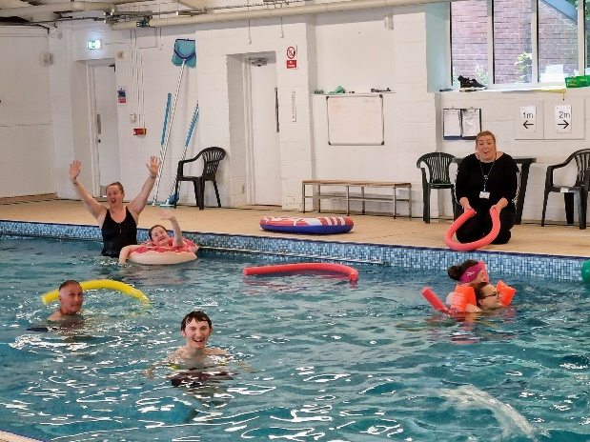
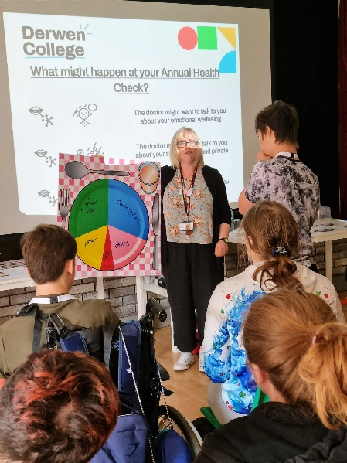
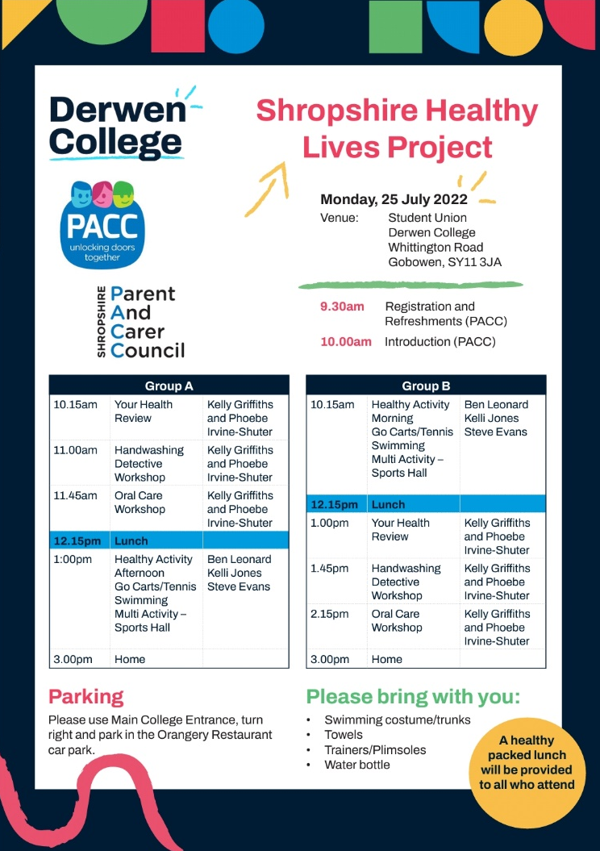
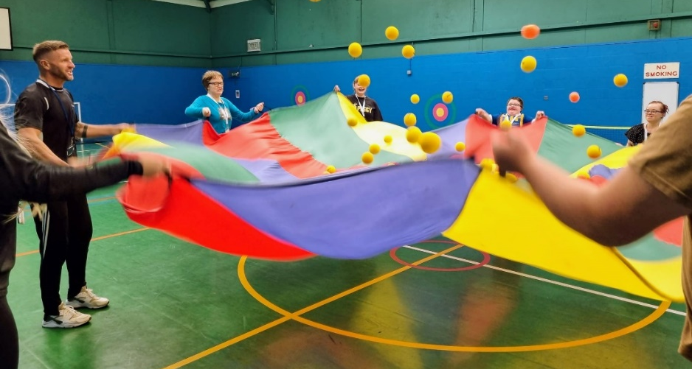
The Programme was launched on Monday 25th July at Derwen College. Attendees were split into 2 groups and did an activity session and health workshops. Activities included swimming, go-karting and multi-sports. Health workshops covered annual health checks, hand hygiene, gut health, dental hygiene, and healthy eating.
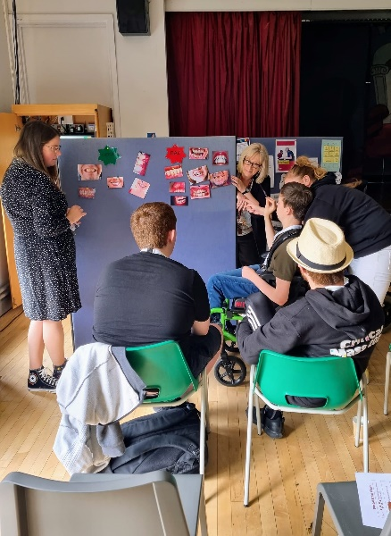

Appendix B: Young Person Needs Table

Name of YP
DOB: | Age:
Name of Parent carer
Emergency contact number
Description of needs
Communication Support Details
Mobility Support Details
Personal Care Support Details
Dietary Requirements/ Allergies
Medical Needs
Techniques/ Special Interests/ Engagement
Emergency First Aid Permission
Photograph Permission

Appendix C: HLP Promotional Flyer

Appendix D: Personalised Timetable
Healthy Lives SEND Summer Programme

Name of YP
Date | Activity | Time | Location
25.07 (Mon) | Welcome Event and activities: Swimming, multi-sports, go-karts, health workshops.  Please bring: swimming clothing, towel, trainers, water bottle | 9:30-3:00 | Derwen College, Whittington Road, Gobowen, Oswestry SY11 3JA
27.07 (Weds) | Get fit with multi-sports and gym  Please bring a water bottle and wear suitable clothing | 10:00-12:30 | Shrewsbury Sports Village Sundorne Road, Shrewsbury SY1 4RQ
30.07 (Sat) | Disco with your favourite songs  With Eve from Kiddley Divey.  Pizza and soft drinks included | 7:00-9:00pm | Willow Lodge Centre - Aspirations, Tilstock Crescent, Shrewsbury, SY2 6HW
1.08 (Mon) | Day at the farm and build a greenhouse  Please bring packed lunch, water bottle and wear suitable footwear | 10:00-2:30 | Greenacres Farm, Fenemere Lane, Baschurch, Shrewsbury, SY4 2JA
3.08 (Weds) | Get fit with multi-sports and gym  Please bring a water bottle and wear suitable clothing | 10:00-12:30 | Shrewsbury Sports Village Sundorne Road, Shrewsbury SY1 4RQ
10.08 (Weds) | Get fit with multi-sports and gym  Please bring a water bottle and wear suitable clothing | 10:00-12:30 | Shrewsbury Sports Village Sundorne Road, Shrewsbury SY1 4RQ
23.08 | Sports day Event | 10:00-12:00 | Bethphage, Innage Lane Resource Centre, Innage Lane, Bridgnorth, WV16 4HL

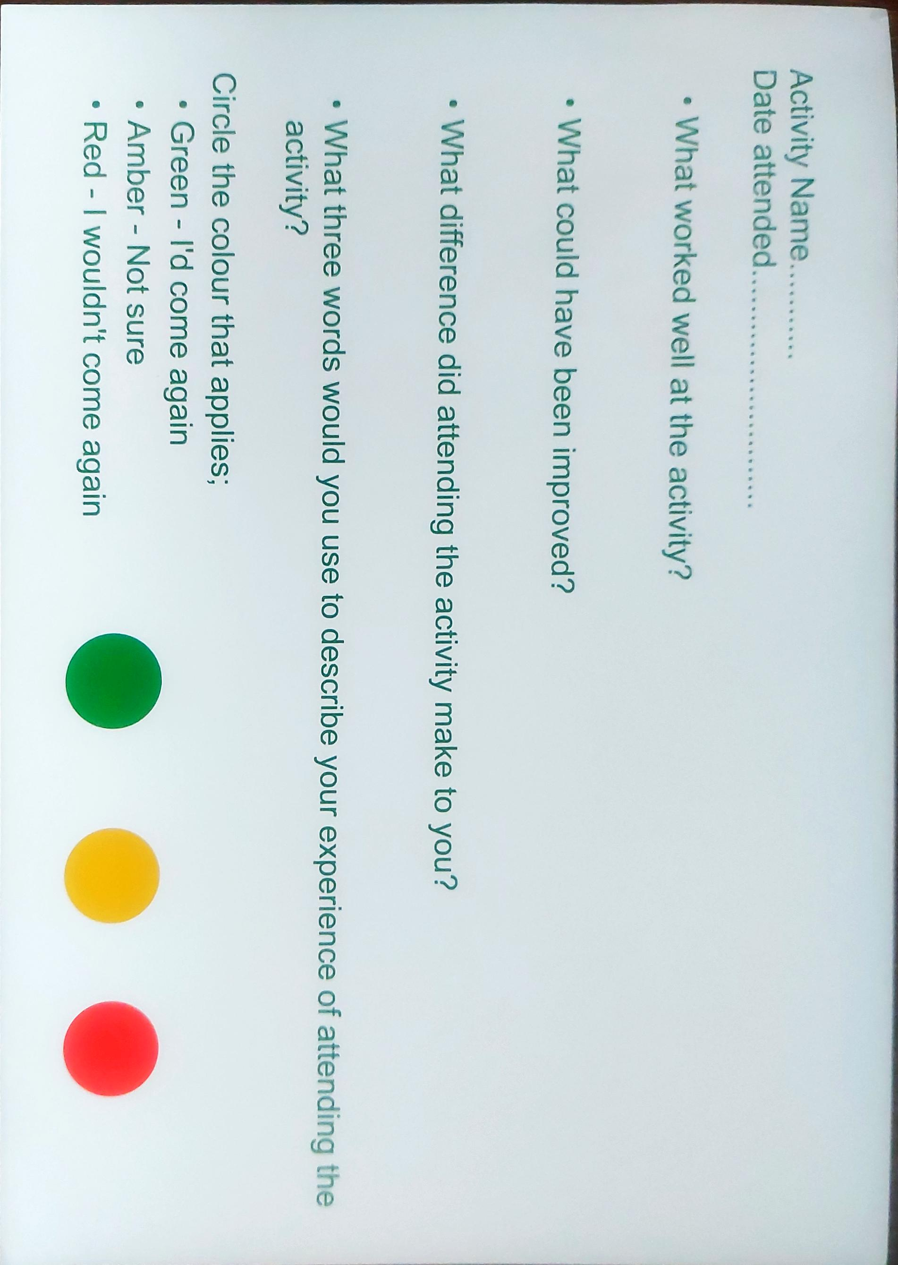
Appendix E: Feedback Cards

